Springtime at the Farm Pop-up Farm Craft
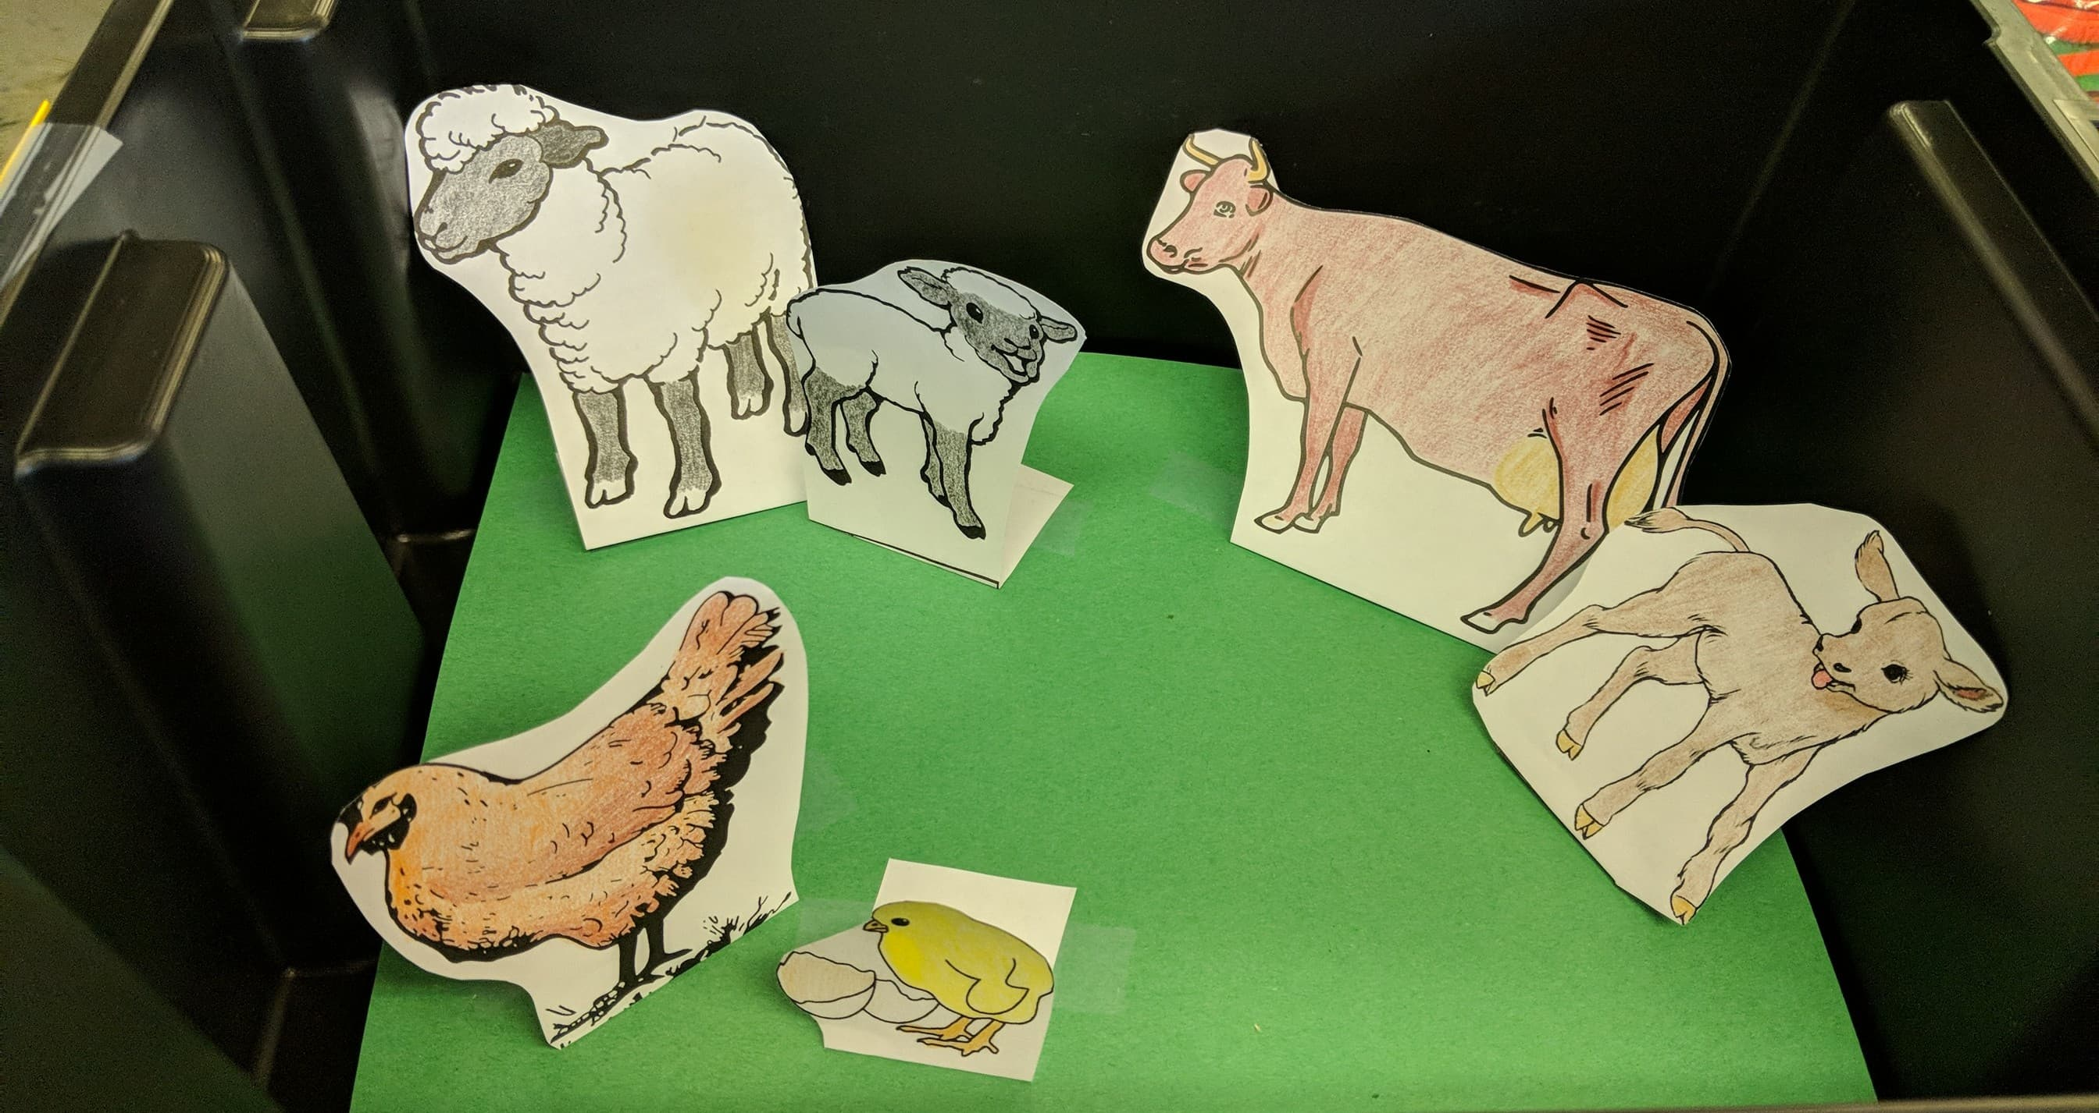
Print out the sheets below, colour and cut them out, glueing them to a piece of paper.

