Cooking with Razr Chef’s Hat Craft
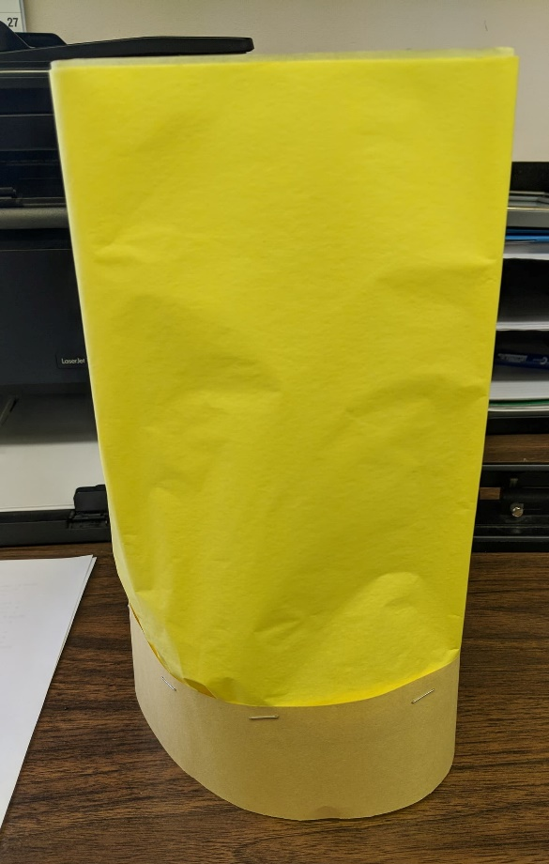
You’ll Need: Tissue paper, construction paper, and a stapler.
1. Measure the circumference of your head and cut the construction paper to be that length.
2. Using 3-4 layers of tissue paper, line the tissue across the top of the construction paper and staple it.
3. Staple the construction paper and tissue paper so that it makes a hat.

